**Project Initialization and Planning Phase**

| Date | June 2024 |
| --- | --- |
| Team ID | 739708 |
| Project Name | EcoForecast: AI-powered prediction of carbon monoxide levels |
| Maximum Marks | 3 Marks |

### Define Problem Statements(Customer Problem Statement Template):

The challenge is to develop an AI-powered system that can accurately predict carbon monoxide levels in real time and forecast future concentrations based on various influencing factors. This system should integrate data from multiple sources, such as fixed and mobile sensors, weather conditions, traffic patterns, and historical CO data. By leveraging machine learning algorithms and advanced data analytics, the goal is to create a predictive model that can provide timely alerts and actionable insights for city planners, environmental agencies, and the general public to mitigate the risks associated with high CO exposure.

Reference: <https://github.com/decimozs/predicting-carbon-monoxide-levels/blob/main/PredictCarbonMonoxideLevels.py>

**Example:**

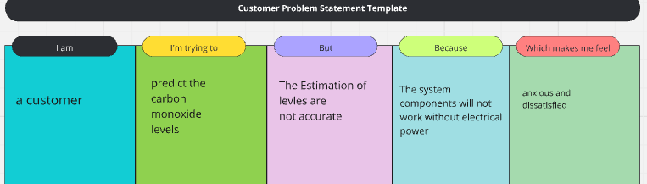

| **Problem**  **Statement (PS)** | **I am** | **I’m trying to** | **But** | **Because** | **Which makes me feel** |
| --- | --- | --- | --- | --- | --- |
| PS | A data scientist working on environmental health | Develop a predictive model for carbon monoxide levels to help mitigate health risks | I'm encountering difficulties with data quality and the complexity of environmental factors affecting carbon monoxide levels | the available data is often incomplete, inconsistent, and influenced by numerous unpredictable factors such as weather, traffic, and industrial activities | concerned about the reliability and accuracy of the predictions, impacting the effectiveness of the health risk mitigation efforts |